Arş. Gör. Kübra ADALI BLM3590 Statistical Data Analysis

**Deadline:** **08.01.2023 23:59**

Statistical Data Analysis Project

Oğuzhan Topaloğlu

Ç19052025 – Group 1

*Computer Engineering,*

*Faculty of Electrical-Electronics,*

*Yıldız Technical University*



Istanbul, 2023

**1. General Information**

In this project, I have written 2 files (main.py, my_functions.py) to do the requirements of the project. my_functions.py file contains all of the statistical functions and main.py file uses these functions to calculate, plot and print the results. main.py file is made of 6 sections which are named as section 0,1,2,3,4 and 5. In this report I will explain the details of these functions and give the plotted graphs in the appendix.

**2. Section 0 & 1**

Section 0, simply prints the project’s and my name to the console along with my student ID. Section 1, imports the dataset that was downloaded from <https://www.kaggle.com/datasets/abcsds/pokemon> and named “Pokemons.csv”. I also remove all rows that contain null values in any column as preprocessing. This means that I will be only investigating relationships between pokemons that have only 1 type rather that 2.

**3. Section 2**

In this section I create 4 plots.

The first plot is a scatter plot and it shows the relationship between the Total and HP attributes of the pokemons. It seems like it has a positive linear relationship but there’s a lot of noise and few outliers.

The second plot is a bar plot that shows the count of Pokemons in each generation. It seems like generation 1,3 and 5 has the most number of pokemons in video games while generation 6 is having the least number of pokemons.

The third plot is a line plot that shows the Total attribute of pokemons as the generations change. It seems like pokemons are the strongest when they’re generation 4 and the weakest when they’re generation 2. And it also seems like the smallest change it Total attribute happens between generation 5 and 6.

The fourth plot is box plot showing the minimum, maximum, quartile 1-3 and interquartile range of the Total attribute.

**4. Section 3**

In this section I calculate the descriptive statistics (min, max, count, range, mean, mode, standard deviation, coefficient of variance, quartile 1-3 and the interquartile range) of each numerical column and print them to the console using a package called tabular to make it look better. While calculating the quartiles, I also check if the quartile index is an integer or not. For example, if I get the index as 3.62, that means that the quartile should be equal to “x3 + (x4 – x3) * 0.62” rather than just being equal to x3. This is called linear interpolation and it’s necessary to get more accurate results while calculating quartiles.

**5. Section 4**

In this section I do 3 t tests using the do_t_test_for function. The first test shows that the difference in means between the Total stat of Generation 1 and Generation 3 Pokemons is not statistically significant. The second test shows that the difference in means between the Defense stat of Fire-type and Water-type pokemons is not statistically significant. The third test shows that the difference in means between the Attack stat of Generation 1 and Generation 2 Pokemons is not statistically significant.

In the do_t_test_for function I used this formula we learnt during class:

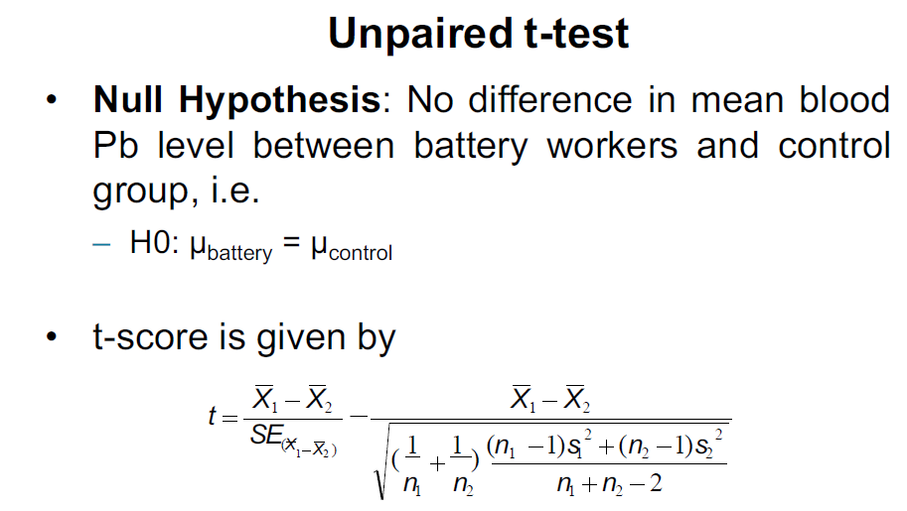

**6. Section 5**

The Pearson correlation coefficient is a measure of the linear relationship between two continuous variables. It can range from -1 (perfect negative correlation) to 1 (perfect positive correlation), with a value of 0 indicating no correlation. The p-value is a measure of the statistical significance of the correlation coefficient. A small p-value (generally less than 0.05) indicates that the correlation is statistically significant, while a large p-value (greater than or equal to 0.05) indicates that the correlation is not statistically significant. The calculate_pearson_corr_for function calculates the Pearson correlation coefficient by looping through the elements of the two input data series, calculates the t-statistic based on the correlation coefficient, and then calculates the p-value based on the t-statistic using the error function (erf). It then prints the Pearson correlation coefficient and p-value to the console.

I use this calculate_pearson_corr_for function to do 3 tests:

- Total stat and Generation number (there’s no significant relationship between them)

- Sp. Atk and Sp. Def stats (there is a significant relationship between the two variables)

- Attack and Defense stats (there is a significant relationship between the two variables)

**7. Appendix (Chart Code & Graphs from Section 2)**

def open_plot_windows(df: pd.DataFrame) -> None:

    plt.figure(1) # Plot 1: Scatter plot for showing the relationship between Total and HP

    sns.scatterplot(x=df['Total'], y=df['HP'])

    plt.xlabel('Total')

    plt.ylabel('HP')

    plt.figure(2) # Plot 2: Bar plot for showing the count of Pokemons in each generation

    sns.barplot(x=df['Generation'].value_counts().index, y=df['Generation'].value_counts().values)

    plt.xlabel('Generation')

    plt.ylabel('Number of Pokemons')

    plt.figure(3) # Plot 3: Line plot for showing the Total attribute for each generation

    sns.lineplot(x=df.groupby('Generation')['Total'].mean().index, y=df.groupby('Generation')['Total'].mean().values)

    plt.xlabel('Generation')

    plt.ylabel('Mean Total')

    plt.figure(4) # Plot 4: Box plot for Total

    sns.boxplot(x=df['Total'])

    plt.xlabel('Total')

    plt.show() # Calling plt.show() at the end so they all get opened in seperate windows

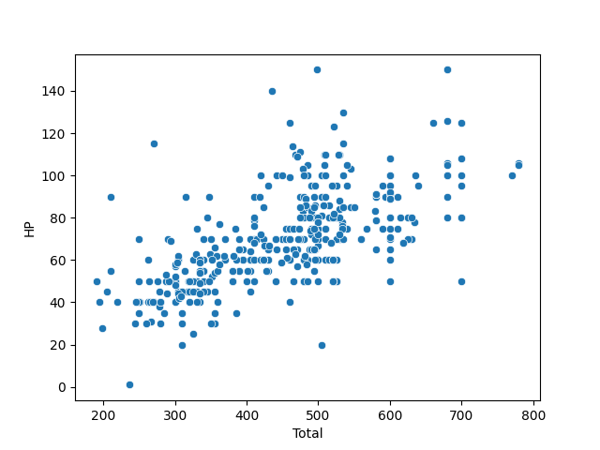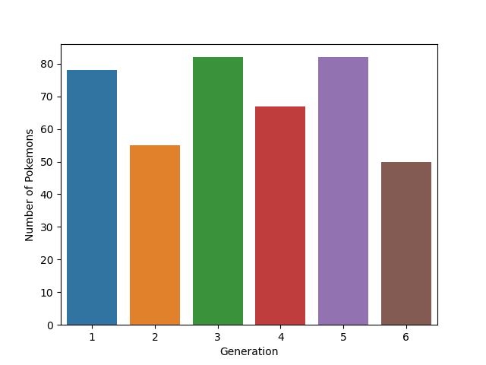

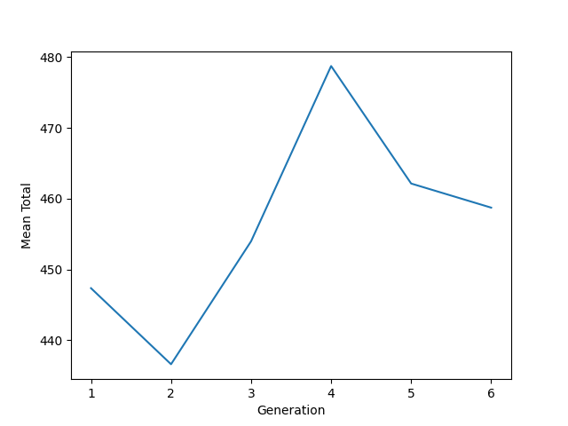

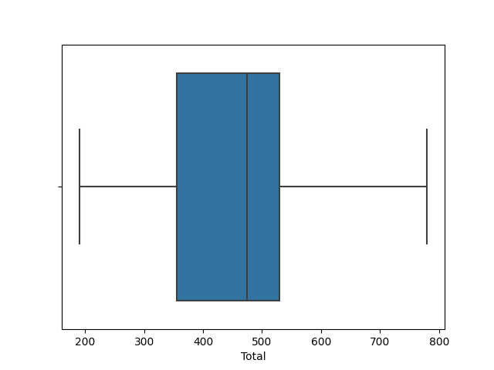

**NOTE: rest of the code can be found in the “src” folder that’s inside the ZIP file. I couldn’t fit all of it in here since there’s a max page limit which is equal to 5. (I sent an email about this but didn’t get an answer...)**